CNOOC Fudao Held 2018 Youth Skills Competition

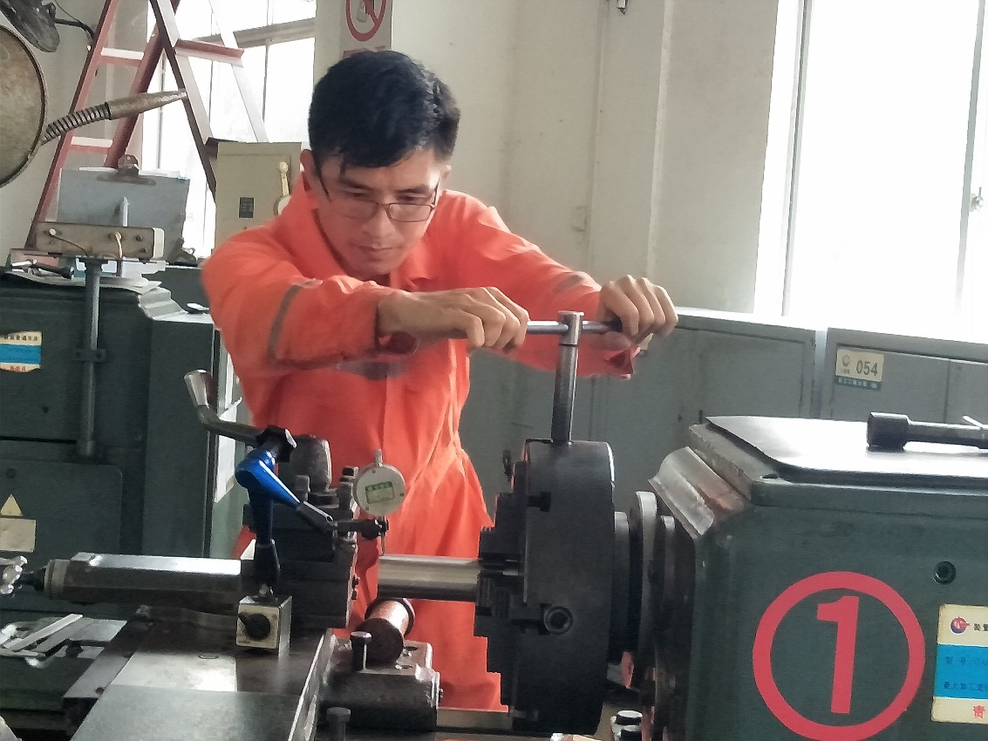

Recently, CNOOC Fudao Limited held the 2018 Youth Skills Competition in Hainan, which aims to enhance the practical skill level of its mechanical engineering staff, while establishes a team with outstanding skills and stringent disciplines.

